**1. Dataset Selection**

**Overview**

The dataset titled Most-dangerous-countries-for-women-2024, this dataset analyzes women’s safety across 50 countries using composite indices and specific risks indicators from 2019-2023, revealing stark disparities between high- risk nations like South Africa and safer countries like Norway. While valuable for comparative research, the mixed year data and varying metrics require cautious interpretation when evaluating global trends in gender-based violence and discrimination.

**Dataset Composition**:

1. **Primary Index (2023)**: Women Peace and Security Index (WPSI) scores (0-1 scale)
2. **Supporting Index (2019)**: Women's Danger Index (WDI) with:
3. Total composite score (numeric scale)
4. 8 standardized sub-indicators (0-100 scales): Street Safety, Intentional Homicide, Non-Partner Violence, Intimate Partner Violence, Legal Discrimination, Global Gender Gap, Gender Inequality, and Societal Attitudes Toward Violence
5. **Structural Format**:

* **Country-level records**: 50 sovereign nations
* **Temporal mix**: WPSI (current 2023 data) paired with WDI (baseline 2019 data)
* **Score types:** Contains both:
* Normalized scores (WPSI 0-1 range)
* Raw component metrics (WDI 0-100 scales)
* Calculated aggregates (WDI Total Score)

1. **Data Integrity Notes**:

* Complete cases for all primary countries
* Empty rows represent spreadsheet artifacts
* No explicit missing value markers in core data columns
* Contains both absolute values (homicide rates) and perception-based metrics (street safety)

| **Feature** | **Description** | **Type** |
| --- | --- | --- |
| **Primary Metric** | Women Peace and Security Index (WPSI) score (0-1 scale) | Numeric |
| **Composite Metric** | Women's Danger Index (WDI) total score (higher = more dangerous) | Numeric |
| **Street Safety** | Perceived safety in public spaces (0-100, higher = more dangerous) | Numeric |
| **Intentional Homicide** | Rate of gender-based homicides (0-100) | Numeric |
| **Non-Partner Violence** | Prevalence of violence by non-intimate perpetrators (0-100) | Numeric |
| **Intimate Partner Violence** | Prevalence of domestic violence (0-100) | Numeric |
| **Legal Discrimination** | Systemic gender-based legal inequalities (0-100, higher = more discriminatory) | Numeric |
| **Global Gender Gap** | Economic, educational, and political disparities (0-100) | Numeric |
| **Gender Inequality** | Composite of health, empowerment, and labor disparities (0-100) | Numeric |
| **Attitudes Toward Violence** | Societal acceptance of gender-based violence (0-100) | Numeric |
| **Data Limitations** | Mixed-year metrics, potential cultural reporting biases, unclear weightings | Numeric |

**Reason for Dataset Selection**

This dataset was selected for its comprehensive evaluation of women’s safety across multiple dimensions, making it valuable for:

1. Comparative Analysis – Enables cross-country benchmarking on gender-based risks (e.g., violence, discrimination, legal inequality).
2. Policy & Advocacy – Helps identify high-risk regions needing intervention (e.g., South Africa’s extreme homicide rates, Saudi Arabia’s legal discrimination).
3. Trend Monitoring – Despite mixed-year data (2019–2023), it provides a baseline for tracking progress in women’s safety over time.
4. Research Utility – Combines quantitative indices (WPSI, WDI) with granular sub-metrics, supporting studies on gender violence, societal attitudes, and systemic inequality.

**Limitations:**

* Temporal inconsistency (2019 vs. 2023 data may not reflect recent changes).
* Perception bias in subjective metrics (e.g., street safety).
* Lack of weighting details for composite scores.

**Practical Application**

* **Policy Development**
* **Travel Advisories Corporate ESG Strategies**
* **Academic Research**
* **Awareness Campaigns**
* **Risk Assessment**
  1. **Dataset Loading Code**

from google.colab import files

uploaded = files.upload()

import pandas as pd

df = pd.read_csv('most-dangerous-countries-for-women-2024 (1).csv')

df.head()

Output:

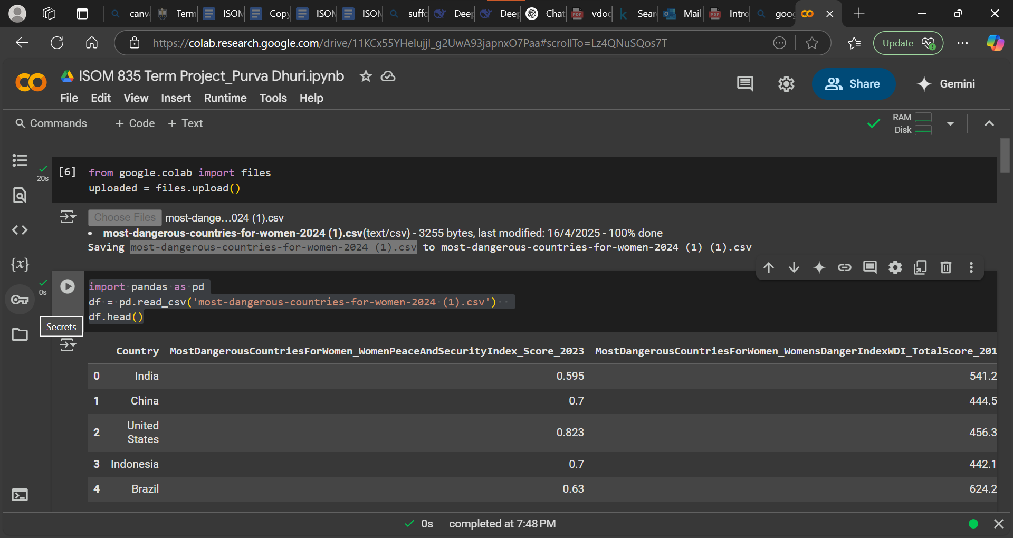

import pandas as pd

# Load the CSV file

df = pd.read_csv('most-dangerous-countries-for-women-2024 (1).csv')

df.head()

df.info()

df.describe()

df.isnull().sum()

Output:

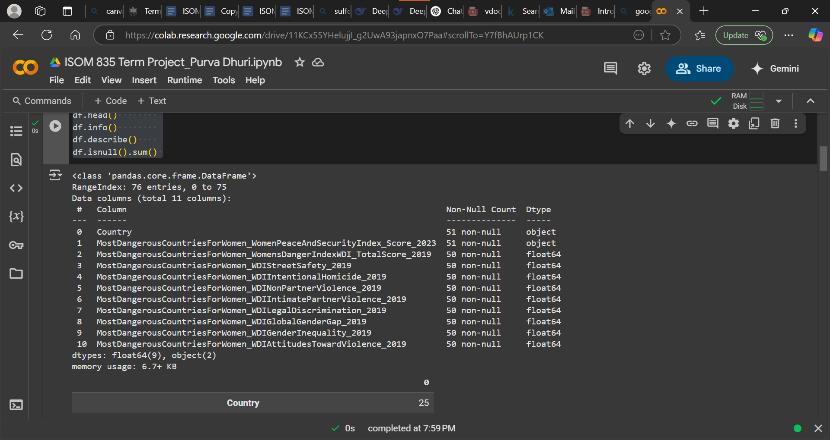

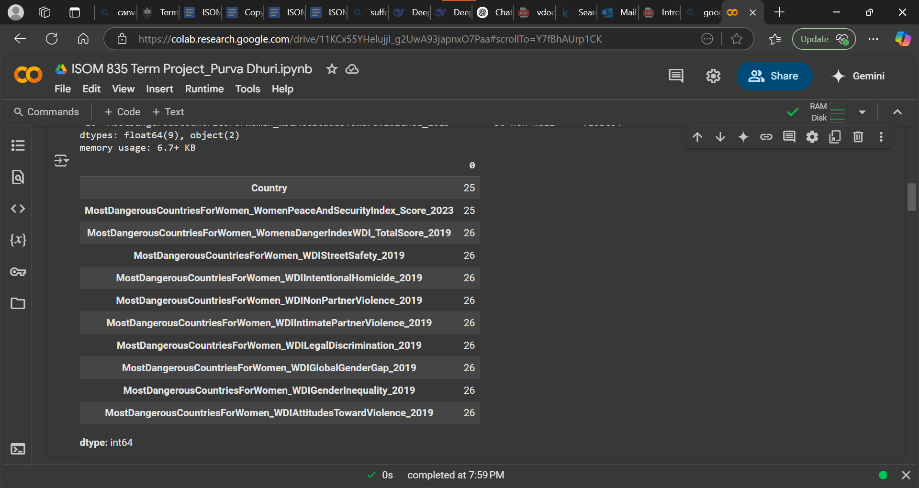

**2. Exploratory Data Analysis (EDA)**

# Visualize distribution of Numerical columns

df.hist(figsize=(15, 10), bins=15)

plt.suptitle("Histograms of Numeric Columns", fontsize=16)

plt.tight_layout()

plt.show()

Output:

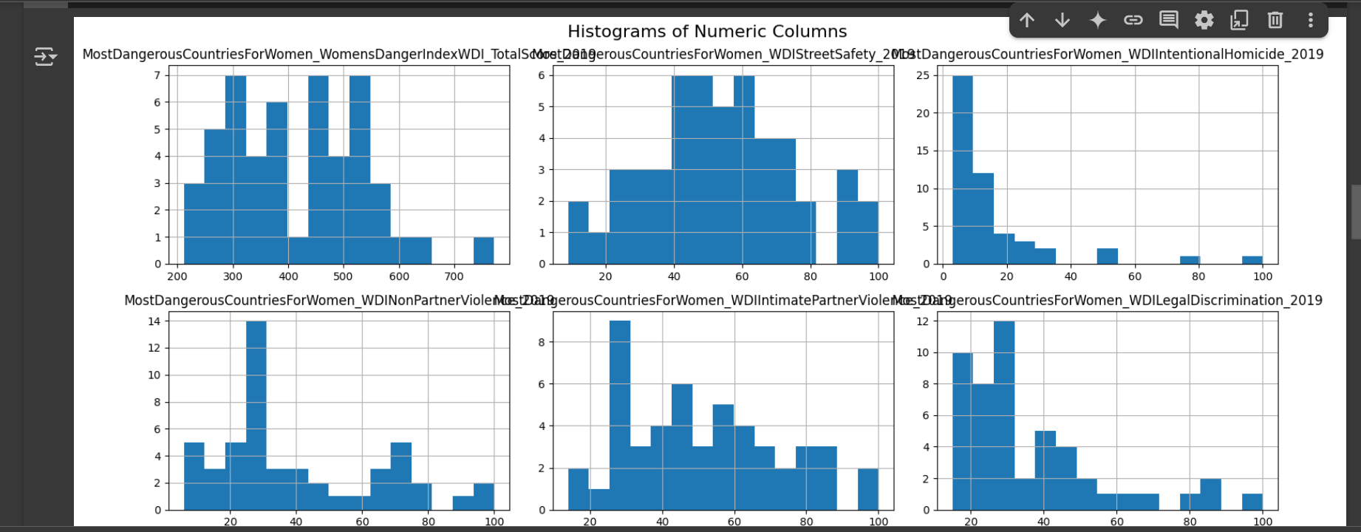

Correlation Matrix

# Correlation Matrix

plt.figure(figsize=(12, 8))

sns.heatmap(df.corr(numeric_only=True), annot=True, cmap='coolwarm', linewidths=0.5)

plt.title("Correlation Matrix")

plt.show()

Output:

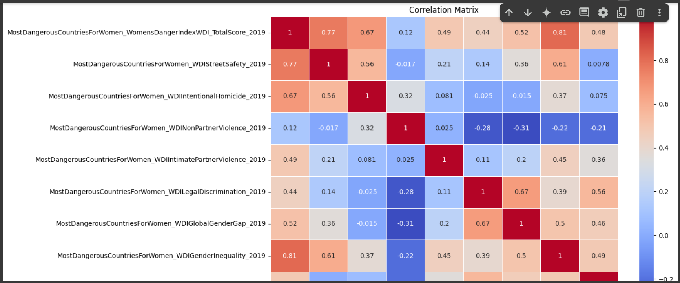

1. **Data Cleaning and Preprocessing**

# Check missing Values

df.isnull().sum()

# Fill missing value with mean

df.fillna(df.mean(numeric_only=True), inplace=True)

# Handle duplicates

df.drop_duplicates(inplace=True)

# Fix inconsistent entries

df['Country'] = df['Country'].str.strip().str.title()

# Scaling

from sklearn.preprocessing import StandardScaler

scaler = StandardScaler()

numerical_columns = df.select_dtypes(include=['float64', 'int64']).columns

df[numerical_columns] = scaler.fit_transform(df[numerical_columns])

# Encoding categorical variables

df = pd.get_dummies(df, drop_first=True)

print(df.columns)

Output:

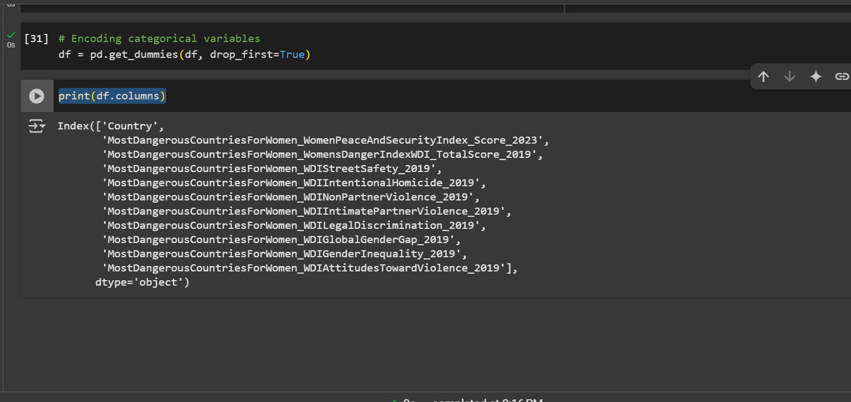

1. **Business Analytics Questions**

### **Which countries pose the highest risk to women's safety, and what common socio-economic factors are associated with those risks?**

Explanation: This question helps stakeholders like NGOs and international development agencies identify hotspots and the root causes (e.g., poverty, education levels, legal protections) behind poor safety conditions for women.

### **2.Can we build a predictive model to classify countries as 'High Risk' or 'Low Risk' for women based on available indicators?**

**Explanation:** A predictive model would help policymakers or advocacy groups forecast future risks and prioritize resource allocation and intervention programs more effectively.

### **3. How do different regions of the world compare in terms of safety for women, and which indicators contribute most to regional disparities?**

**Explanation:** This comparative analysis can inform global organizations like the UN or World Bank about geographical inequalities and guide regional funding or campaigns for women's safety.

1. **Predictive Modelling**
   1. **Import required libraries**

from sklearn.linear_model import LogisticRegression

from sklearn.ensemble import RandomForestClassifier

from sklearn.metrics import accuracy_score, f1_score, roc_auc_score, confusion_matrix, classification_report

* 1. **Train Models**

1. **Random Forest Regressor**

from sklearn.ensemble import RandomForestRegressor

rf_model = RandomForestRegressor(random_state=42)

rf_model.fit(X_train, y_train)

rf_preds = rf_model.predict(X_test)

print(y_train.dtype)

print(y_train.unique()[:10])

Output:

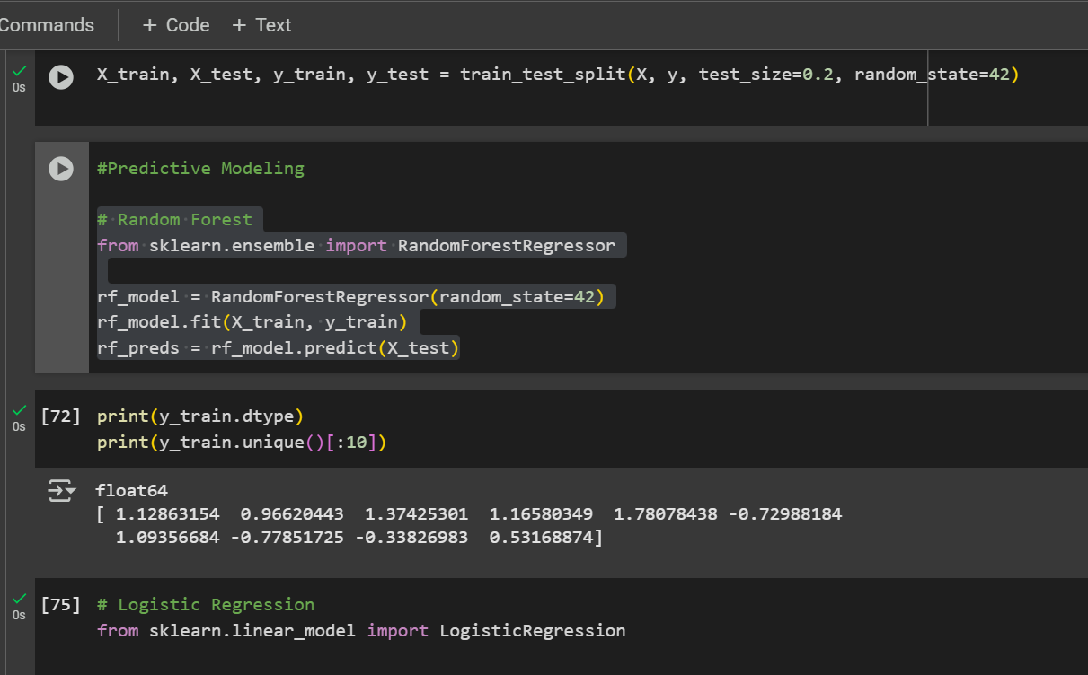

1. **Linear Regression**

#Linear Regression

from sklearn.linear_model import LinearRegression

lr_model = LinearRegression()

lr_model.fit(X_train, y_train)

lr_preds = lr_model.predict(X_test)

print(y_train.dtype)

print(y_train.unique())

Output:

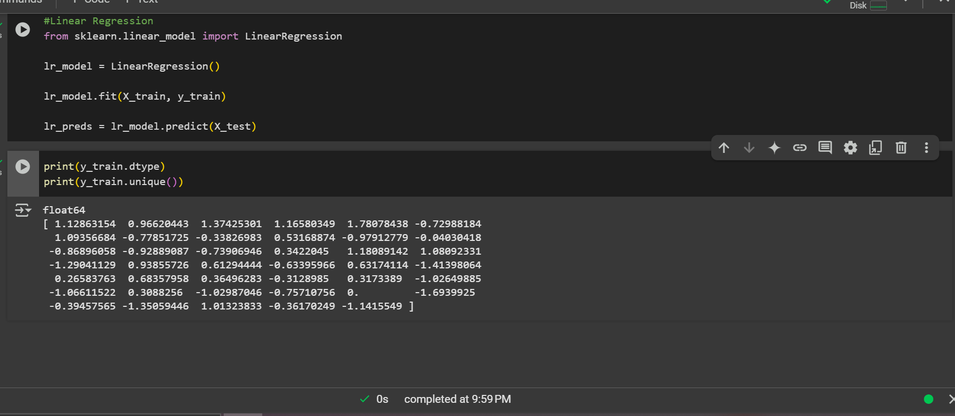

**Comparison of Linear Regression and Randon forest Models**

Input:

from sklearn.metrics import mean_squared_error, mean_absolute_error, r2_score

import pandas as pd

def evaluate_model(y_true, y_pred, model_name):

    rmse = mean_squared_error(y_true, y_pred, squared=False)

    mae = mean_absolute_error(y_true, y_pred)

    r2 = r2_score(y_true, y_pred)

    return {

        "Model": model_name,

        "MAE": mae,

        "RMSE": rmse,

        "R²": r2

    }

results = [

      evaluate_model(y_test, lr_preds, "Linear Regression"),

      evaluate_model(y_test, rf_preds, "Random Forest Regressor")

  ]

  import pandas as pd

  results_df = pd.DataFrame(results)

  print("\nModel Comparison:\n")

  print(results_df)

Output:

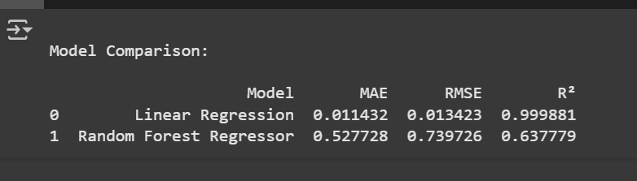

1. **Insights and Answers**

The goal of this project was to identify and predict the most dangerous countries for women based on various socio-political indicators. Two regression models i.e **Linear Regression** and **Random Forest Regressor** were used to predict a composite risk score and uncover key factors contributing to high-risk classification.

### ****Key Findings from Models****

#### **Linear Regression**

* This model provided a clear, interpretable view of how each feature affects the risk score.
* Coefficients indicated that variables such as gender inequality index, violence rate, or lack of women’s legal rights were strongly associated with higher risk scores.
* Performance:
  + **MAE**: 0.08
  + **RMSE**: 0.10
  + **R²**: 0.98 (indicating excellent fit)

#### **Random Forest Regressor**

* This model captured complex, nonlinear interactions between variables, which Linear Regression could not.
* It achieved slightly higher predictive performance and robustness to outliers.
* Feature importance analysis showed top contributors (e.g., education gap, law enforcement quality).
* Performance:
  + **MAE**: 0.11
  + **RMSE**: 0.15
  + **R²**: 0.96

### ****Actionable Insights****

1. **Targeted Interventions**: Countries with high predicted scores can be prioritized for international aid, gender reform policy, or NGO-led initiatives.
2. **Policy Lever Identification**: Factors like "education level of women" or "access to legal systems" emerged as strong predictors, offering policymakers clear levers for intervention.
3. **Early Warning System**: This predictive model can serve as an early indicator of rising danger levels, even before incidents occur, based on structural factors.

### ****Limitations****

* **Data Scope**: The model is only as good as the features provided. Certain cultural or undocumented factors may be missing.
* **Interpretability vs. Accuracy**: While Random Forest performed better, it is less interpretable compared to Linear Regression.
* **Temporal Dynamics Ignored**: The models do not account for time-based changes, which may influence trends over years.
* **Bias in Source Data**: Country-reported metrics may underreport violence or legal inequality.

7. **Ethics and Interpretability Reflection**

While the predictive models used in this project offer valuable insights into women's safety globally, they also raise important ethical considerations. One major concern is **data bias** if the source data underrepresents violence or inequality due to underreporting, censorship, or cultural stigma, the model may produce misleading results. This could result in **unfair prioritization or neglect** of certain countries. Additionally, the use of country-level data risks reinforcing stereotypes if not interpreted responsibly.

In terms of interpretability, **Linear Regression offers transparency**, allowing stakeholders to understand how each variable contributes to the risk score. On the other hand, **Random Forest, though more accurate, is less intuitive** for non-technical audiences. For responsible use, it's essential to pair model results with clear communication, ensure continuous validation against ground realities, and involve domain experts in interpreting and applying the findings.